Chapter 1
DNA Structure + Replication
Genetics – Mechanisms + Patterns of inheritance through transmission of coded chemical instructions from one generation to the next. (Depends on DNA)
DNA – Common genetic material (differences in connections/sequence determines different species) carries information coded in genes
Nucleic Acids – DNA (deoxyribonucleic acid) or RNA (ribonucleic acid)
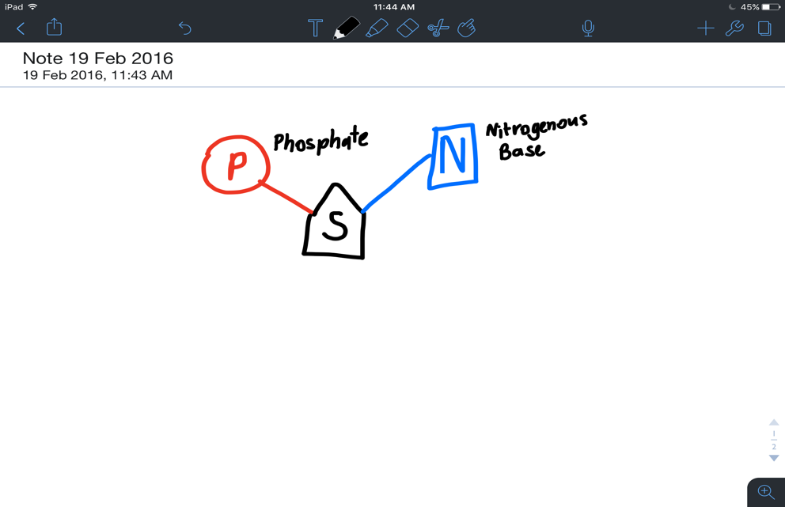
Both composed of nucleotides
- 5 Carbon Sugar
- Negatively Charged Phosphate group
- Nitrogenous Base
RNA
- One long strand of nucleotides
- Functions in protein synthesis
- Ribose as sugar
Bases: Adenine (A), Uracil (U), Guanine (G), Cytosine (C)
DNA
- 2 long strands of nucleotides wound to form a double helix
- Encodes Heritable Information
- Deoxyribose as sugar
Bases: Adenine (A), Thymine (T), Guanine (G), Cytosine (C)
Nucleotide Strand
- Sugar binds to phosphate
+ Strand has one phosphate bound to sugars 5th carbon, and next phosphate attached to its 3rd carbon. Strand is said to run from 5’ to 3’ (prime)
+ Opposite occurs on complimentary strand
- Hydrogen bonds hold strands together, bond between bases is:
A Bonds with T or U (x2 Hydrogen Bonds)
G Bonds with C (x3 Hydrogen Bonds)

Stages of DNA Replication (Occurs during interphase)
- DNA Helicase (an enzyme) ‘unzips’ double helix by breaking hydrogen bonds
- In the nucleus, free nucleotides attach to exposed bases, with help from DNA Polymerase
- DNA Ligase seals new stretches into continuous strand that rewinds
Cells
- All cells originate from pre-existing ones
Asexual Reproduction
- Living things originate from one parent, offspring closely resembles parents
Sexual Reproduction
- Living things originate from 2 parents (usually) and thus DNA comes from 2 sources. The difference from parents is greater.
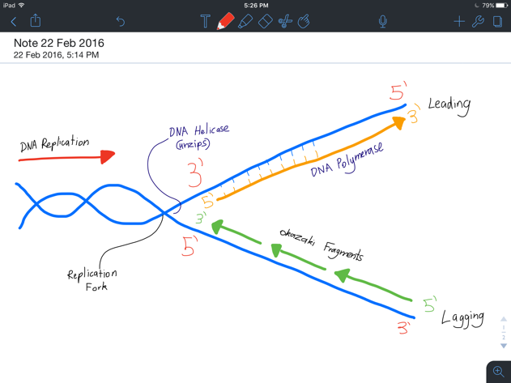

Chromosomes in Eukaryotic Cells
- DNA is found in nucleus, chloroplasts, and mitochondria
  - DNA in mitochondria and chloroplasts similar to plasmids (Plasmid: A linear or circular double-stranded DNA that is capable of replicating independently of the chromosomal DNA) in prokaryotes (endosymbiotic theory)
- DNA visible during replication + when stained (coiled around histone proteins)
- Nucleus: All DNA + associated proteins known as chromatin
  - One DNA Molecule known as chromosome
Karyotypes
Chromosomes occur in pairs – one from each parent
Karyotypes show pairs by ordering them by size and banding (location of genes)
Human Chromosomes
- Species characterised by No. of chromosomes in each cell
- Nucleus of human somatic (body) cell
  - 46 chromosomes in 23 pairs
  - 22 pairs are homologous (matching) + autosomes (regular cells)
  - One pair are sex chromosomes (XX Females and XY Males heterosome)
- Chromosomes in somatic cells are diploid or 2n
Genes in Eukaryotes
- Location of genes along DNA known as locus. Genes found at same locus in homologous chromosomes
- Alternative forms of the same genes known as allele
- Diploid organisms have 2 alleles for each gene

Chromosomes in Prokaryotic Cells
- DNA in single circular chromosome (region referred to as nucleoid)
  - No membrane bound organelles in prokaryotic cells
- Chromosomes in direct contact with cytoplasm, connected to cell membrane at a point
- Smaller rings of DNA (Plasmids) found around cytoplasm
  - Code for non-essential genes
  - Replicate independently of nucleoid
  - Easily transferred between species
- Generally (some exceptions)
  - Proteins cause supercoiling so it fits
  - Haploid
  - Little repetitive + non coding DNA
  - No histones

Mitosis
Cell Division
Eukaryotic cells pass on instructions via
- Nuclear division in somatic cells (mitosis)
- Cytoplasmic division (cytokinesis)
Results in 2 diploid identical daughter cells
- Have identical sets of chromosomes
Cell Cycle
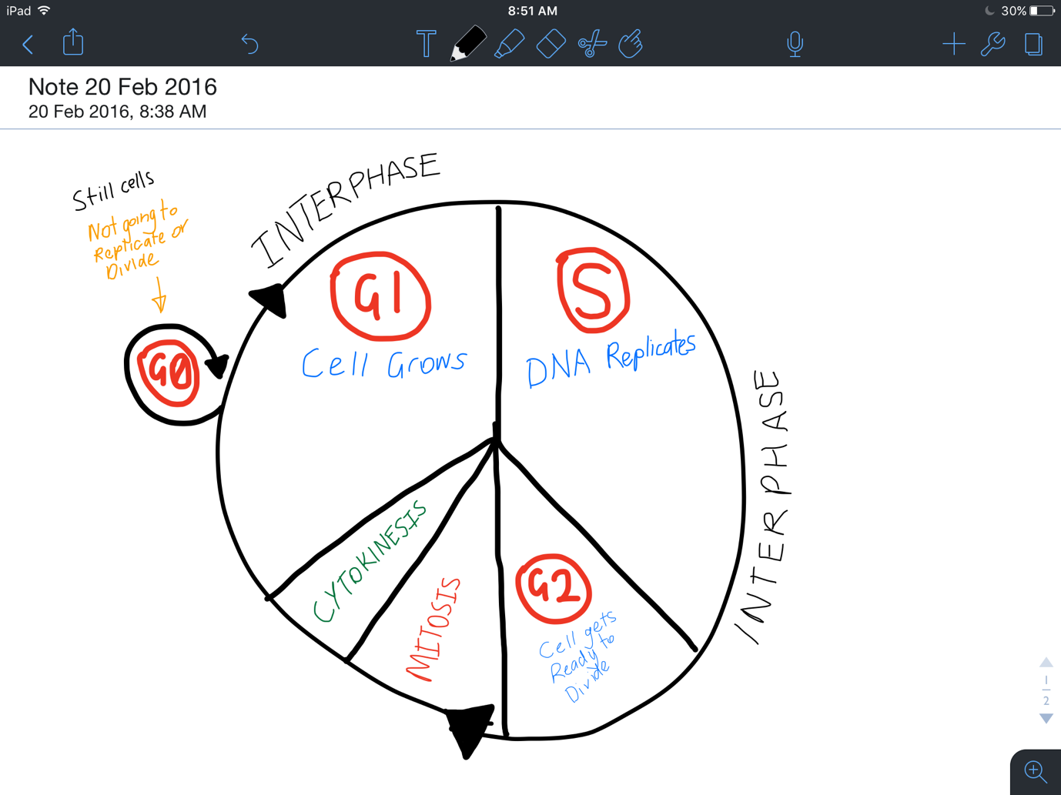
Sequence of events from one division to the next

Cell Cycle Length
Varies in different cells
- Shorter cell cycles in areas where ‘wear and tear’ is common
Phases identified by measuring changes in cell volume or amount of DNA

Stages of Mitosis

- Interphase | + Chromosomes not visible  + Right before mitosis, centrioles visible  Chromatin threads become thicker + shorter
- Prophase | + Chromatin condense + become visible double strands (2 chromatids + 1 centromere)  + Spindle forms from centrioles (X)  + Nucleolus disappears  + Nuclear membrane breaks down
- Metaphase | + Chromosomes line up at equator
- Anaphase | + Spindle fibres attach to centromere  + They contract and pull chromatids apart  + Chromatids move to opposite poles  Now known as chromosomes again
- Telophase | + Chromosomes de-condense (less visible)  + New nuclear membrane forms  + Nucleoli forms  + Spindle disassembles  + Cytoplasm pinches in
- Cytokinesis | + Cells split and results in 2 daughter cells

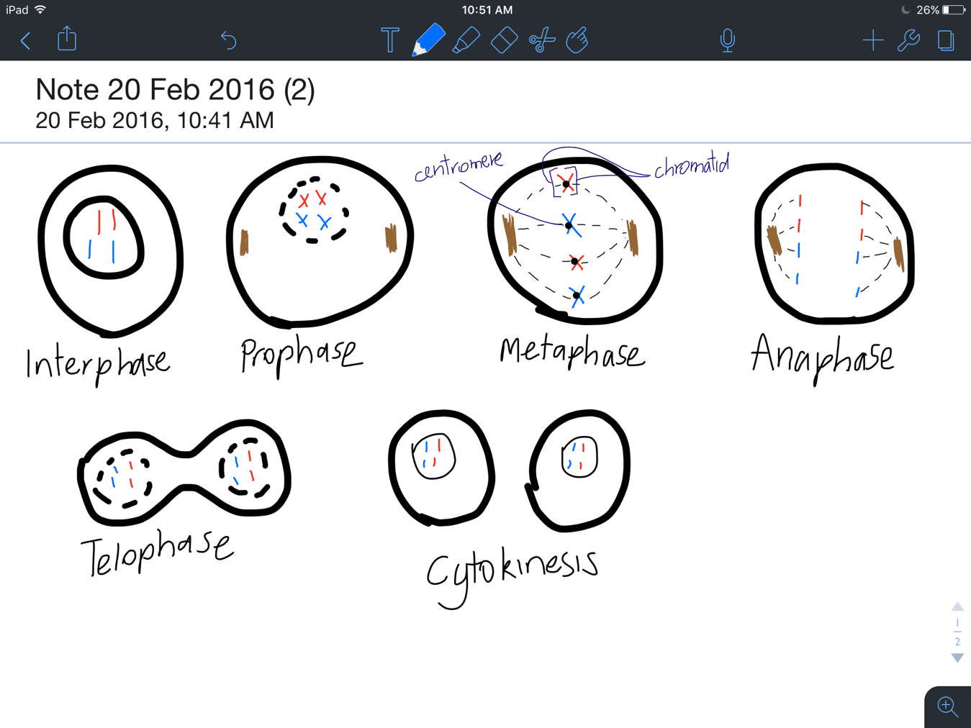

Cytokinesis – Plant Cells
Cytoplasm divides by the formation of a cell plate in the middle of the cell
- Made by parts of cell wall fusing with parts of spindle
- Cellulose deposited at this site, forming a wall
- Divides parent cell into 2 daughter cells
Cytokinesis – Animal Cells
Cytoplasm divides via cleavage
Plasma membrane around middle of cell draws together to form cleavage furrow
- Continues to develop until it meets
- 2 daughter cells
Asymmetrical division sometimes occurs (unequal distribution of proteins)

Binary Fission
How prokaryotes reproduce
Includes:
- DNA replication
- Chromosome segregation
- Cytokinesis
Result is still 2 daughter cells with same chromosomes
- DNA Copies attach to two different parts of the membrane. As the cell pulls apart it splits the original chromosome.
- A wall forms across the cell
This process occurs in mitochondria + chloroplasts which divide independently of nuclear DNA

Meiosis + Fertilisation
Occurs in special organs
- Results in production of gametes
Prevents doubling up of DNA in the final product
- From 1 diploid (46) cell 4 haploid (23) cells
- Called ‘reduction division’ because chromosome No. reduced by half.

Stages of Meiosis
Interphase I | + DNA replicates and is visible
Prophase I | + Chromosomes condense  + Nucleolus disappears  + Centrioles move to poles  + Spindle forms
Metaphase I | + Chromosomes move + line up along equator  + Homologous chromosomes (maternal + paternal) sit next to each other  + Spindles from each pole attach to 1 homologous chromosome each  + Crossing over may occur leads to variation between parents and offspring
Anaphase I | + Homologous chromosomes split and are pulled to poles (disjunction)  + Each homologous pair divides independently of others
Telophase I + Cytokinesis I | + Spindle breaks down  + Cell starts to separate  + Nuclear membrane reforms  + Cells separate completely
Second Stage ( Occurs in 2 separate cells)
Interphase II | + Break between meiosis I + II but no replication occurs
Prophase II | + Nuclear membrane breaks down again  + New spindles form
Metaphase II | + Chromosomes move to equator (all in one line this time)  + Spindles attach to centromeres
Anaphase II | + Chromatids split & move to poles  + Now referred to as chromosomes again
Telophase II + Cytokinesis II | + Cytoplasm begins to divide in both of the cells, spindle fibres break down, nuclear membrane reforms,  + Both cells separate completely again

End Product
- Four Haploid (n) Cells (23 chromosomes in each)
- 22 autosomes + 1 sex chromosome

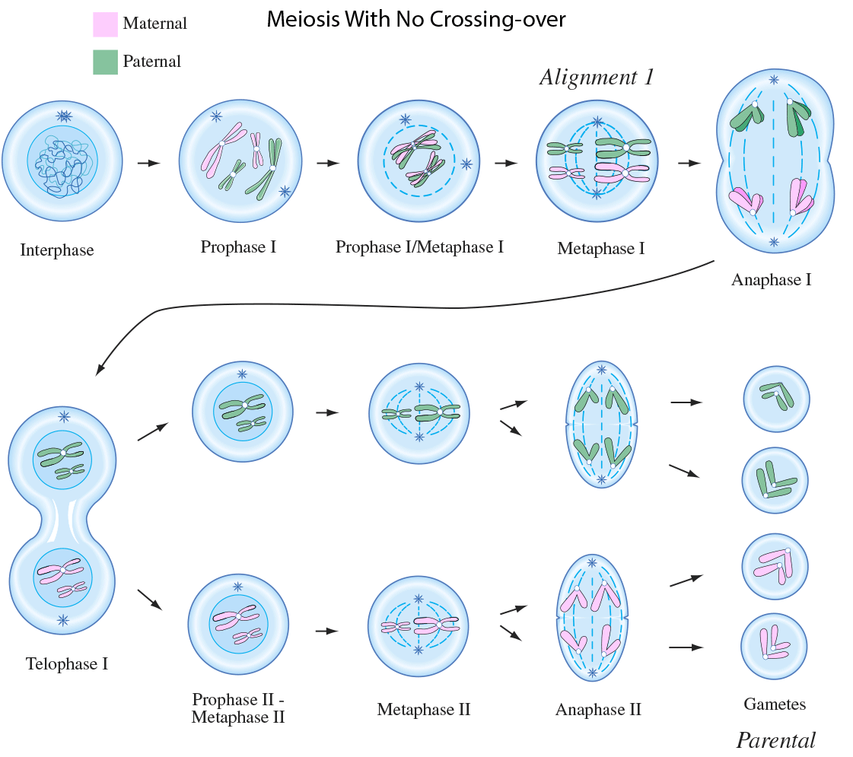

Mitosis VS Meiosis
For growth, repair and replacement | For production of gametes
Occurs in somatic cells | Occurs in reproductive organs
One cell division | 2 cell divisions
Results in 2 cells | Results in 4 cells
Daughter cells contain diploid (2n) No. of chromosomes | Daughter cells contain haploid (n) No. of chromosomes
Process of reproduction for asexual organisms (binary fission) | For sexual reproduction
No variation between daughter cells | Variation between daughter cells

Sex Determination
In humans
- Females: XX
- Males: XY

Cell Death
Cells do not divide forever
Apoptosis: Programmed cell death. All cells have this programme and can activate it
Failed Apoptosis: Not good, ie. Cancer

Transcription
Proteins
- Essential to cell structure and functioning
Specialised functions; highly suited to task
- Structure and function of cells depend on protein produced in it

Enzymes
- Biological Catalysts
  - Speed up reactions, without undergoing change itself
  - Enables cellular metabolism (reactions) to occur at a rate that sustains life

Protein synthesis
- Proteins are made up of amino acids (about 20 different amino acids)
  - Order of amino acid determines protein made

Transcription
- RNA Polymerase helps DNA unwind
  - 2 strands of DNA exposes, one is a template stand the other is a non-template strand
- RNA polymerase attaches to a promoter region (TATA Box) at the start of a gene and adds complimentary RNA nucleotides to template strand
- Moves along strand until stop signal reached
- mRNA (messenger RNA) released as a single strand
- DNA zips up and rewinds
mRNA Editing
- Pre mRNA modified before it leaves nucleus
  - Methylated cap added to 5’ end
  - Poly-A tail (lots of adenines) added to 3’ end
- Helps in stability, export + translation
Splicing
- Most genes have regions of bases that do not code for essential amino acids
  - Introns (IN – They stay in)
- Regions of bases that do code for essential amino acids
  - Exons (EXIT – They leave)
- Introns removed via splicing
  - Spliceosomes ‘cut’ mRNA at ‘spurs’
- Exons remain and leave nucleus as mature mRNA
Alternative Splicing
- Same mRNA strand can have different exons spliced together
- Leads to different proteins

Replication | Transcription
Whole DNA molecule a template | Small part of DNA used as a template
Nucleotides added by DNA polymerase | Nucleotides added by RNA Polymerase
Double-stranded DNA is molecule | Single strand RNA is the product
Product found only in nucleus | Product found in nucleus and cytoplasm

Translation
Process by which ribosomes synthesize polypeptides from mRNA made in transcription

Attachment to ribosome
- Once spliced, mRNA moves through cytoplasm and attaches to ribosome at 5’ methylated cap
  - Ribosomes attached to rough ER and ribosomes free in the cytoplasm
- Ribosomes ‘scan’ mRNA for START codon (AUG)
  - Codon = base pair triplet

Transferring Amino Acids
- When start codon is detected, transfer RNA (tRNA) attaches to mRNA
  - tRNA has anti-codon on one end and amino acids on the other
- tRNA matches every consecutive codon (3 base pairs) with an anti-codon
- Each time new amino acid is added to growing polypeptide strand via peptide bonds
  - Peel off tRNA as they link to one another
- Continues until stop codon is reached

End Product
- Polypeptide (amino acid) strand release
- tRNA released
- mRNA broken down and releases free nucleotides

Energy
- Majority of ATP produces by cells goes into this process

Polyribosomes
- Ribosomes may occur in chains
- All bind to one mRNA strand
  - Allows large No. of polypeptides to be produced in short time
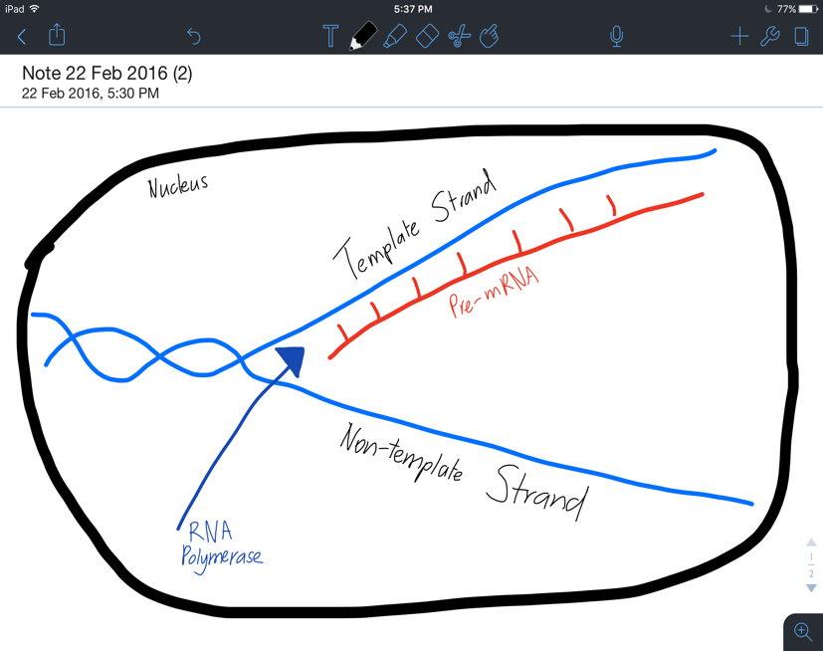

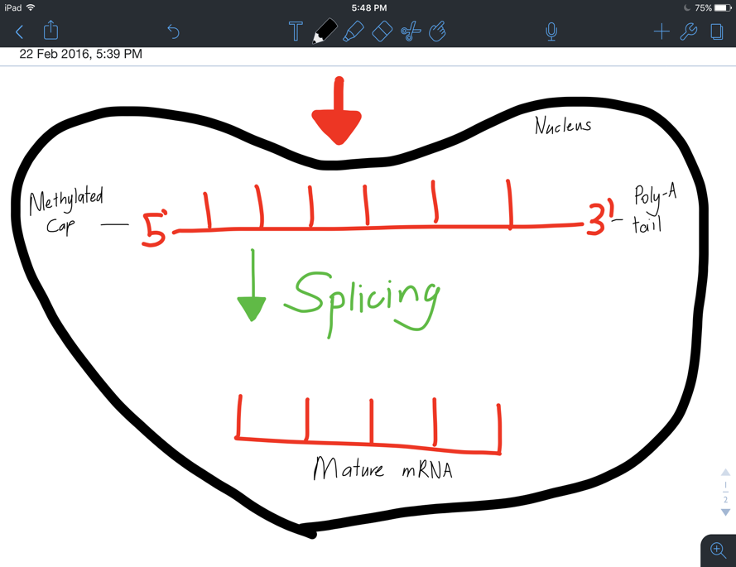

Gene Expression
All cells have the same DNA, but they’re all different
- Do not express all cells of genome at the same time
- Unneeded genes inactivate so energy not wasted making unneeded proteins

Central Dogma
- DNA RNA Proteins
- Doesn’t always occur in this direction
  - EG. HIV produces DNA from RNA

Coding + Non-coding DNA
- Coding DNA (exons) make up 1% of the entire genome
  - 80% of genome transcribed at one point
  - Unknown what non-coding areas do

Definitions
Gene Expression – Gene is transcribed into mRNA + translated into proteins
Gene Regulation – Process in cells that enables gene to be expressed in specific cells at specific times

Genes ‘on’ or ‘off’
- Nucleosome: DNA double helix wound around histone proteins (chromatin)
- When wound tight, RNA polymerase can’t access genes – turned off
- When DNA is in an open configuration (relaxed) RNA polymerase can access genes – turned on

DNA in Eukaryotes
- Most genes switched off
  - Only housekeeping genes switched on
  - Make proteins for basic cellular function

DNA Methylation + Gene Expression
When cytosine in DNA have methyl groups attached
- Methyl groups stick out and block RNA polymerase
- Attract phosphates of DNA causing more condensing
- Genes switched off

Genes active with no methylation (or by addition of acetyl)
eg:
X in-activation
- Methylation inactivates an X-chromosome in female mammals (eg. Tortoise shell cats)
Imprinting
- Methylation silences one of 2 alleles (eg. Beckwith-Widemann syndrome)

Products of Genes + Gene Expression
Regulatory proteins can regulate expression
Transcription factors (TFs) are proteins that bind to DNA
- Activators – Help DNA unwind (gene on)
- Repressors – Prevent RNA Polymerase binding (gene off)
- Are specific
- Activator can also be a repressor

Regulation of Translations
mRNA binding proteins attach (before AUG) + prevent translation
miRNA complement mRNA
- Creates 2 stranded RNA which can’t be translated

Environmental Influences
- Environment affects gene expression based on what is needed
(eg. Himalayan Rabbit)
- Diets
  - Some foods can cause DNA methylation (eg. Agouti Mouse)

Gene Expression in Prokaryotes
- Most genes turned on
  - Repressed when transcription products not needed
  - eg. E. Coli + Lactose/Glucose

Environment + Bacteria
- Environment also affects prokaryotes (tryptophan + e. coli)
- When low, gene activated + e. coli can produce own tryptophan
- When high, tryptophan binds to repressor, activates it + gene is turned off
- Conserves energy

Variation
Differences exist between members of the same species
- Intraspecific variation
Types of phenotypic variation
- Morphological
- Biochemical
- Physiology
- Behavioural

Alleles and Variation
- Each copy of a gene isn’t always identical
- Phenotype (physical expression of a gene) affected by:
  - Combination of alleles (genotype)
  - 1Environment

Variation in alleles caused by:
- Crossing Over – Swapping over of sections of chromatid during metaphase 1
- Random assortment – Random chance of which egg meets which sperm
- Non-disjunction – Failure of chromosomes to separate properly during division
- Mutations

Variation in chromosomes
- Alteration can occur in large sections of chromosomes. This can be seen in the karyotype

Variations in Chromosome number:

Monoploidy
- 1 as apposed to regular 2n
- EG. Many ants, bees, wasps
  - Males 1n, Females 2n
  - Males make sperm by mitosis
  - Half info lies dormant until fertilization (female) or pathogenesis (male)
- Monoploidy more conservative but diploid organisms more common because defective alleles can be masked

Polyploidy
- Triploid (3n) + Tetraploid (4n) possible if cell divisions fail to produce haploid gametes
- Common in plants and algae
- Organisms associated with larger size/power but have reduced fertility
- Lethal in humans

Aneuploidy
- Addition or loss of one or more chromosomes from the cell
  - Trisomy: Extra Chromosome
  - Monosomy: Loss of Chromosome
- Miscarriages are common
- Occurs via non-disjunction

Types of Aneuploidy Disorders
Name | Type | Chromosomes Involved | Symptoms
Down Syndrome | Autosomal trisomy | Chromosome 21 | Distinct facial features  Intellectual disability
Kleinfelter Syndrome | Sex linked trisomy | XXY | More feminine features  Infertile
Wolf-Hirschhorn syndrome | Autosomy Monosomy | Partial loss of chromosome 4 | Distinct facial features  Intellectual disability
Turner Syndrome | Sex linked monosomy | XO | Short Stature  Infertile

Types of Mutations
Mutations – an alteration to a DNA sequence, involving single bases, parts of a chromosome, or a whole chromosome

Point Mutation
- Simplest form of mutation
- A single nucleotide is affected
  - Also called single nucleotide polymorphism
- Substitution – one nucleotide replaced by the other
  - Silent/synonymous Mutation
    - New base results in codon that codes for the same amino acid
  - Missense Mutation
    - New base changes amino acid
  - Nonsense Mutation
    - New base creates a stop codon (early termination)
- Insertions + Deletions
  - Addition or removal of a nucleotide
  - Usually results in a frame-shift mutation, which affects all codons ‘downstream.’

Mutations in Chromosomes
- Deletion – Removal of section of DNA
- Inversion – Section of DNA flipped
- Translocation – Section of one chromosome swaps with section of non-homologous chromosome
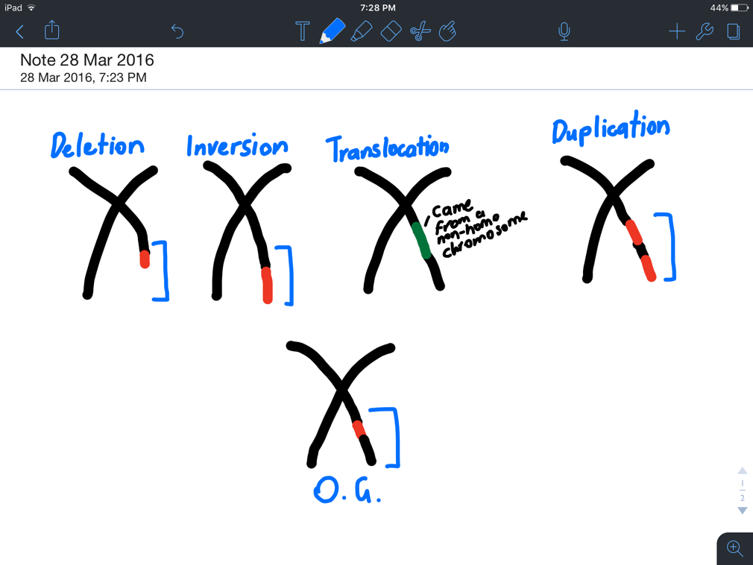
- Duplication – Copy is made of a section
Effects of mutations on survival
- Altered Base --> Altered Codon --> Altered Amino Acid --> Altered Protein
- May impact survival

Neutral Mutation
- Survival of organism is not affected
  - Occurs with silent mutations
  - Sometimes with missense mutations if new amino acid has similar properties to the original

Deleterious Mutation
- Disrupts function of encoded proteins + impacts ability to survive
- Nonsense Mutations
  - An organism can survive if they have a copy of a normal allele
  - Otherwise usually serious effects

Transposable Element
- Cause death if occurring in exon
- Less harmful in introns + can be passed on if in gametes

Beneficial Mutations
- Missence mutations can change function of original protein for the letter
  - Eg. Having one allele of sickle cell mutation prevents catching of malaria
- Nonsense mutations may eliminate harmful proteins
  - Eg. Some people have nonsense mutation eliminates surface protein needed by HIV to enter cells

Causes of Mutations
Spontaneous
- Due to errors in cell division
Induced
- By physical/chemical mutations

Mutation Research
- Mutations arise spontaneously
- Environmental influences affect mutation rate
- Mutation are persistent
- Mutations usually mean a disadvantage
  - Premature death means mutations don’t accumulate in populations

Effects of Mutations
- Invisible, subtle, severe
  - Rarely beneficial
- Effect depends on whether mutation is in
  - Somatic Cells
  - Germ-line Cells (gametes)

Somatic Cell Mutations
- Occurs only in affected body cells + any daughter cells produced by mitosis
  - All other cells back mutation
- Mutation usually builds up, accelerates cell division + terminates apoptosis
- Cant be inherited

Germ-line Mutations
- Affects gametes, so can be inherited
  - If so, present in every cell of offspring
- Often leads to developmental abnormalities that cause spontaneous abortion
  - If birth occurs, offspring may be born with severe disorders
- If consistently passed on, new allele has entered population

Errors in Cell division
- Mutations usually occur in S phases (DNA is exposed and venerable)
  - Chemical alterations of bases may cause incorrect pair binding
  - DNA structure may be damaged (ROS)
- Errors often fixed in G2 – but checkpoints can fail

Physical Mutations
- Various types of radiation that cause DNA damage
UV light --> Structural distortion cross linking neighbouring nucleotides
X Rays --> Gene and chromosome aberrations
Nuclear Radiation --> Breaks in DNA strands

Chemical Mutations
- Usually work by substituting a base in for another
- Some change structure of bases
- Some resemble bases and ‘slip in’

Biological Agents
- Mutations caused by invasive pathogens (eg: bacteria and viruses)
  - DNA becomes permanently integrated with hosts

Horizontal Gene Transfer
- Plasmid inserted into host
  - Plasmid contains genes which code for enzyme that cuts host DNA and insets part of plasmid
  - Gene then programmed to produce what the bacterium requires
- Useful in Gene Therapy
- Some viruses can cause HGT in gametes
  - Results in transposable elements shifting from one area on a chromosome to another

Genetic Engineering

Biotechnology
- The use of living things to make new products or systems

Genetic Engineering
- Is the changing of the genetic sequence of an organism through human use of modern biotechnology techniques
- Can be used to:
  - Switch Genes on or off
  - Remove Genes
  - Introduce Genes
- Genetically engineered organisms called
  - Genetically Modified Organisms (GMOS)
  - Transgenic Organisms
    - Have DNA of other species in their genome
Cutting DNA
- Cutting segments of DNA into known sequences
- Cutting tool:
  - Enzymes called restriction endonucleases (or restriction enzymes)

Restriction Enzymes
- Cut DNA into restriction fragments
  - Specific: Different enzymes Different cutting site
- Restriction enzymes occur naturally in bacteria
  - Named after bacterial chain
  - About 4000 exist

Cutting Products
- Cuts of restriction enzymes have many forms:
  - Overhanging strands: sticky ends
  - No exposed strands: blunt ends

Recombining DNA
When 2 samples of DNA need to be combined:
- DNA Ligase used
- Forms phosphodiester bonds (a group of strong covalent bonds between a phosphate group and two 5-carbon ring carbohydrates) between 2 fragments

Improving DNA ligase function
Achieved by using restriction enzymes that create sticky ends (blunt ends also work but not as efficiently)
- 2 DNA fragments are cut with the same enzyme. Have the same sticky ends with the same complimentary strands exposed
DNA Ligase can easily recombine the 2 fragments
- Even if unrelated species (known as recombinant DNA technology)
Amplifying DNA
When larger quantities are needed of a sample of DNA
- EG: small samples collected at a crime scene
Polymerase Chain Reaction (PCR) can increase amount of desired DNA
- Makes use of DNA polymerase

Components of Polymerase Chain Reaction
- Template DNA
- DNA Polymerase (an enzyme)
- Buffer Solution (for enzyme function)
- Supply of 4 nucleotides
- Primers X2
  - Short sequences of single stranded DNA Complimentary to start and end of DNA template
  - Acts as a starting point for DNA polymerase

Steps of PCR
- Denaturation – DNA heats to 95°C so hydrogen bonds break
- Annealing – Cooled to 50-60°C. Primers attached to DNA template
- Extension – Heat to 72°C. DNA polymerase synthesises new strands using free nucleotides in the buffer solution
- Repeat process until desired amount is acquired

Gene Analysis
Can be achieved by
- Gel Electrophoresis
- DNA probing
- DNA sequencing

Gel Electrophoresis
- A technique that separates fragments of DNA according to size + charge
- DNA has an overall negative charge
  - Due to the phosphate backbone
- Used to separate fragments through agarose gel

Gel Electrophoresis Method
- Gel melted and poured into mould
- Comb placed in mould before it sets
- Creates walls when removed once gel is set
- Gel placed in Electrophoresis kit, comb removed and buffer solution poured on top
- DNA samples inserted into wells
- Plugged into power pack with positive and negative electrodes attached at either end
- When current is flowing, fragments are repelled from negative end and moved to positive end
- Smaller strands of DNA can get through faster
  - Fragments separate which results in coloured bands
  - Smaller fragments form bands further from the DNA wells

Determining the size of fragments
- Achieved with molecular size markers
  - DNA sample inserted into one of those wells, the number of DNA fragments is already known.

Use of Gel Electrophoresis
- Matching 2 or more samples of DNA
  - Can be used to determine a common source or a related source

Gene Probing
- Gene Probe
  - A tool that can search for specific regions in a genome
  - A single length of stranded DNA
  - Is complimentary to a known sequence of DNA

Gene Probing Method
- DNA being tested (usually for a disorder) is heated to separate the double helix
- Single stranded probe introduced and will bind to complimentary sequence if it exists
- Probes have a tag (fluorescent dye) which makes them visible

Gene Probing Uses
- Locating parts of a gene after electrophoresis
- Identifying position of a gene
- Identifying allele of a specific gene associated with a disease

DNA Sequencing
- When an exact nucleotide base sequence needs to be known
  - Can help identify point mutations
- Can be done manually (gel electrophoresis) and/or automatically (DNA sequencer)

DNA Sequencing Method
- Four nucleotides labelled with four different coloured dyes
- During electrophoresis, laser scans across gel, detecting dyes
- Computer analysis colour recordings and produced a base sequence (sanger method)

Gene Cloning Transfer and Applications
Gene Cloning
- An alternative to PCR
  - Allows replication of larger segments
  - Permits analysis of any gene or protein
- Plasmids used to insert DNA into bacterium

Steps
- Plasmids extracted from bacteria
- Same restriction enzyme used to cut plasmid DNA + desired DNA (complimentary sticky ends)
- DNA Ligase binds foreign DNA to plasmid DNA (created recombinant plasmid)
- Recombinant plasmid added to bacterial culture
- Replicate (plasmids replicate too)

Adding to Bacterial Culture
- Bacteria taking up recombinant plasmid
  - Transformed
- Transformed bacteria isolated from the rest of the colony
  - Usually via antibiotic selection (antibiotics kills non-resistant bacteria)
  - Plasmid DNA contains genes resistant to antibiotics (they live, others die)

Gene Transfer
- Basis for gene therapy
  - Inserting functional copies of a gene into patient with genetic disease
  - Deleting of gene usually achieved with a vector

Plasmid Vector
- Recombinant plasmid inserted directly
- Not very efficient
  - Plasmid unstable like this

Viral Vector
- Inserted gene into viral DNA/RNA (usually of adeno virus or retrovirus)
  - Need to remove viral genes that cause disease
- Virus inserts this into target cells
- Problem:
  - Human immune system attacks virus
  - Can disrupt gene regulation and cause cancer

Liposome Vector
- Liposome: Small sphere surrounded by bilayer membrane
  - Can fuse with other layers
- Made artificially
- Have molecules on surface that are recognised by specific cells only

DNA Profiling
- Used to compare base sequence of 2 or more individuals to compare how similar they are using short tandem repeats (STR’s) + variable nucleotide tandem repeats (VNTR’s)
  - Sections of non-coding DNA repeated many times
- Number of repeats vary between individuals
  - Similarities of repeats indicate relatedness
- Continue PCR + Gel electrophoresis:
- DNA isolated
- PCR amplifies it
- Amplified DNA separated by gel electrophoresis
- Fragment analysed

Biotech Applications – Agriculture
- Used to modify food crops
  - Higher nutritional value + greater yield
- Achieved through transformation
  - Creating a transgenic organism
  - Gene from one species inserted into another to obtain desired trait

Genes Against Pests
- CSIRO isolated a pest resistant gene, introduced it to a wheat plant
- Bacterium makes proteins toxic to insects
- Good:
  - Less insecticides
- Bad:
  - Resistant strains develop

Genetically Engineered Animals
- Salmon increased growth rate
- Cow’s milk similar to humans
- Pigs that release less phosphorus
- Preserve biodiversity in animals that interbreed

Autosomal Inheritance

Inheritance
- 2 copies of homologous chromosomes
  - 2 copies of genes – may be different to one another
  - Alleles – Alternative forms of a gene
- Inheritance
  - The passing on of characteristics from one generation to the next

Gregor Mendel (Mendalion Genetics)
- Studied pea plants
  - Crossed purebred tall plants with purebred short plants (parental generation)
Father
  - First Filial Generation (F1) all tall
  - Offspring of the F1 (second filial generation) where tall + short
  - ¾ tall, ¼ short

Dominant (capital)
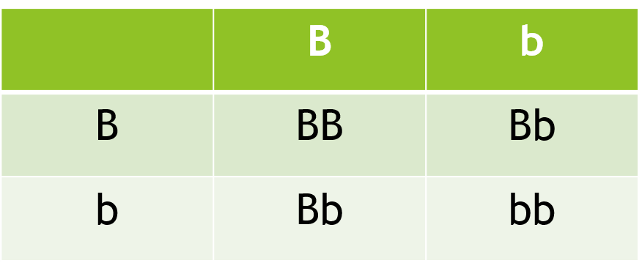
- A phenotype that requires only one copy of its allele to be expressed
Mother
Recessive (lowercase)
- Phenotype that requires only one copy of its allele to be expressed
- Presence of dominant allele will mask recessive
Homozygous (purebred)
- A genotype with 2 identical alleles for a single gene locus (location)
Heterozygous (hybrid, carrier)
- A genotype with 2 different alleles for a single gene locus

Homozygous Dominant = TT
Homozygous Recessive = tt
Heterozygous = Tt

Genotype
- A specific combination of alleles for a particular gene locus
Phenotype
- The actual form taken by a specific feature in an individual based on their phenotype
- Affected by genes + environment (eg. hair colour)

 | B | b
B | BB | Bb
b | Bb | bb
EG:
B = Brown Eyes
b = Blue eyes

Bb X Bb

Genotype: 1/4 BB, 2/4 Bb, 1/4 bb
Phenotypes: Blue eyes 1/4, Brown 3/4

Deadly Combinations
- Mice fur colour (Y=yellow, y=grey)
- A cross between heterozygotes should show 3:1 ratio, however ratio is always 2:1
- YY is homozygous lethal phenotype + offspring die before birth

Lethal Phenotypes
- Many caused by recessive lethal allele
  - Need 2 copies
- Some cause by dominant lethal allele
  - Only need one copy (AA+Aa)
  - Huntington’s Disease

Types of Dominance + Inheritance

Types of Dominance:

Complete Dominance
- One trait is dominant over another
- The homozygous dominant + heterozygous genotypes are expressed as the same phenotype (hair colour)

Incomplete dominance
- One trait is not fully dominant over the other heterozygous phenotype, is a blend between the homozygous phenotypes (snapdragons)

Co-dominance
- No allele is dominant over the other. Both are fully expressed in heterozygous phenotype (shorthorn cattle – heterozygotes are patchy)

Multiple Alleles – Blood Groups
- Where 3X or more alleles exist for a particular gene
- Blood groups is an example

I^{A} I^{A} = A | I^{B} i = B
I^{A} i = A | I^{A} I^{B} = AB
I^{B} I^{B} = B | i i = O

Polygenic Inheritance
- When a characteristic is controlled by more than one gene (human height)
- Continuous variation
  - Showing a range of phenotypes due to being controlled by 2 or more genes
- Discontinuous variation
  - Occurs when only one gene is involved

Types of Inheritance
- Dominant
- Recessive
- Autosomal (trait on autosomes)
- Sex Linked (trait on sex chromosomes)

Sex linked inheritance
- Sex chromosomes contain homologous regions and differential regions
  - Homologous: Same on both chromosomes
  - Differential: Unique to each chromosome
- Genes found in differential regions are sex linked
  - Phenotypes will differ between males and females

X-Linked Recessive
- Males only need one
- Females need recessive on both
- More common in Males
- Affected male cannot pass to son
- Son inherits from mother
- Daughter inherits from both parents

X-Linked Dominant
- Heterozygous female will show phenotype
- Affected individuals must have affected parents
- Males don’t pass on to son, but pass on to daughters (Rett Syndrome)

Y-Linked
- When trait is carries on Y chromosome
- Passed on from father to son
- Females unaffected

Geographic Timelines + Continental Drift

Evolution
- The scientific explanation for the mechanisms that drive species to change over time
Geologic Times of the Earth
- Epoch – Shorter than a period + marked by some ore more significant events
- Period – Division of geologic time
- Era – Comprised of periods and epochs
- Eon – Can be divided into periods, epochs and ages.

All measurements of geological time are given in Mya

Continental Drift
- The floating of earths plates on a fluid mantle
  - Are in constant movement
  - Movement known as plate tectonics (causes earthquakes)

Pangea
- Evidence shows that a supercontinent existed 200mya - Pangea
  - Over 20mya, Pangea split into Laurasia (north) + Gondwana (south)
  - Next 100mya, further separation led to continents we know today

Magnetic Evidence
- Magnetic field changes frequently
- Iron rich minerals in rocks are magnetized frozen compasses, these record orientations relative to position of magnetic poles at time of formation

Changing Climates
- Evidence seen in ice cores

Changing Atmosphere
- First atmosphere of earth had little oxygen
- 2.5bya saw an increase
- Indicates mew plant species

Fossil Record

Fossils
- Preserved remains or traces of an organism
  - Provide evidence of past life
  - May be hard parts or impressions

Fossilisation
- Organisms die and are quickly covered in sediments
  - Depletes oxygen
  - Minimizes decomposition
- Usually found in sedimentary rock
  - Other rock types involve high heat which destroys fossil evidence
- Hard parts make more fossils
  - Soft tissues sometimes preserved as films or impressions

Mineralisation
- Where minerals from sediments replace natural bone/shell
  - Makes remains harder + more likely to fossilize

Types of fossils:
- Petrified fossils
- Moulds
- Casts
- Carbon Films
- Trace fossils
- Preserved Remains

Transitional Forces
- Intermediate state between organism’s ancestral forms + that of its descendants
- Hard to identify due to bias of the fossil record
  - Specific requirements mean only certain remains are fossilized (information missing)

Pace of Evolution (theories of evolutionary pattern)
- Some fossils indicate gradual change of organisms as shape and size transitions to different forms – Gradualism
- Some fossils indicate sudden changes – Punctuated Equilibrium

Gradualism
- Evolution occurs at a steady, slow divergence of lineages at an even pace
- Sudden bursts of evolution are not a real record of evolution but an illusion of the fossil record
  - Appears this way because of absence of fossils

Punctuated Equilibrium
- Apparent bursts of evolution are real
- Species remain stable for a period of time but change quickly into a new species in response to an environmental change
- Accepts existence of transitional forms, but these were so brief that they were not preserved

Fossil Dating

A combination of comparative and absolute dating techniques is used to estimate age of sedimentary rocks and fossils within them.

Comparative Dating
- Used to determine the age of a rock or fossil relative to other rocks or fossils formed nearby
  - Based on knowledge of how sedimentary rocks are formed
- Sedimentary rock laid down in layers called strata
  - Oldest at the bottom, youngest at the top
- Palaeontologists can assign relative ages to fossils based on strata in which they are found

Absolute Dating
- Technique that assigns a numerical age in years to a fossil or rock
  - Based on physical or chemical properties of materials in the rock
- Three main types
  - Radio-dating, Electron Spin Resonance, Luminescence

Radiometric Dating
- Isotopes (elements with a different number of neutrons) may have an unstable nucleus that emits radioactive energy at a measureable rate
- Half-life is the time taken for half of the atoms in the initial sample to decay
  - Carbon-14 breaks down at a known rate to be Nitrogen-14
  - Can measure time taken for original amount to decay to present amount (carbon dating)
- Carbon dating only accurate for samples up to 12000 years old
  - Then other isotopes must be used
- Carbon dating generally not applied to fossils
  - Organic tissue often chemically altered
  - Takes longer than 12000 years to form

Electron Spin Resonance
- Measure properties of electrons in the crystals of minerals
  - Minerals collect electrons at a predicable rate
  - Electrons become fixed and magnetic
  - Magnetism can be measured to give reading
- Amount of radiation divided by background dose rate = age of sample

Luminescence
- Measure characteristics of minerals in rock
- Thermo-luminescence measures light emitted from mineral when heated
- Optically stimulated luminescence
  - Measures light emitted from mineral when exposed to visible light

Evidence for Evolution
“Each slight variation, if useful, is preserved” – Charles Darwin

Steps of Natural Selection
- Overproduction
- Variation
- Competition
- Survival of the Fittest
- Favourable combinations increase

Species Discontinuity
- Geographical Isolation
- Extinction

Phylogeny (Phylogenetics)
- Forks in branch where new species arise
- Populations became so different they could no longer interbreed

Biogeography – Divergent Evolution
- Speciation (development of a new species)
- Result of isolated populations
  - Stops gene flow
  - Different environmental pressures – different adaptations
  - Many diverge enough to produce new species (adaptive radiation - divergence out from a central point)
- Known as divergent evolution

Biogeography – Convergent Evolution
- When unrelated organisms evolve features due to similar environmental pressures (eg. Anteaters)
- Results show up as analogous structures (performing a similar function but having a different evolutionary origin)
- Features that have the same function but not the same structure
  - EG Eye in octopus and human

Comparative Anatomy
- Comparison of morphological structures to show evidence for evolution
- Used to establish evolutionary relationships on basis of structural similarities + differences
Embryology
- All members of phylum chordata (spinal chord), at some point have
  - Dorsal Notochord
  - Pharyngeal Slits
  - Dorsal Nerve Chord
  - Tail
- Similarities suggestive of common ancestor

Homologous Structures
- Common physiological structures shared by different organisms
  - Stems from decent of a common ancestor
- After adaptive radiation
  - Organisms retain basic structure because they have the same genetic history
- EG. All lizards have scales, Leaves are all structurally similar (terrestrial and aquatic), Forelimb of vertebrates all have same basic structure (pentadactyl limb)

Vestigial Homologous Structures (Leftover Structures)
- When homologous structures from common decent stop providing a functional use (eg. Appendix)

Molecular evidence
- Organisms share molecular homologies also
  - EG. DNA
- 2 distantly related species may share similar protein sequences
  - They are subject to the same process of evolution

Genetic Comparison
- In absence of external factors, baseline rate of mutation occurs naturally to DNA
- Mutation Rate
  - Frequency of neutral mutations (in non-coding area)
  - Constant in a species
- Similar mutation rates = more recent common ancestor

Comparative Genomics
- Large amounts of data produced
- Bioinformatics
  - Digital storage, retrieval, organisation, analysis of biological data
- Molecular homologies have application in building phylogenetic trees

Variation in Populations

Variation
- Individuals in populations have a range of phenotypes
- Genetic variation is inheritable
  - Many give individuals an advantage over rest of population
- Variations are basis of evolution

Gene Pools
- Variation in alleles leads to variation in populations
- Gene Pools
  - Total collection of alleles in a population
- Range of variation possible restricted by alleles available in gene pool

Fixed Genes
- 80-85% of genes are fixed
  - Only one allele is possible
- Do not contribute to variation or evolution

Allele frequencies
Genetic Polymorphisms - the condition of occurring in several different forms.
- Refers to the phenotype that are coded for by more than one allele and can therefore can vary
Polymorphic Alleles affected by
- Mutation of alleles
- Immigration
- Emigration
- Reproduction
- Genetic Drift
- Bottleneck/founder effect
Different Genetic Variations Occur By:
Mutation
- Mutations are the source of new alleles from old ones
- Many mutations produce recessive alleles which stay masked
  - But important source of variation especially in response to environmental change

Migration + Gene Flow
- Possible because very few populations are completely isolated
- Gene flow occurs if migrants breed (can add or remove alleles from gene pools)
  - EG. Indigenous Australians lack I^{b} blood group gene

Genetic Drift
- Random changes in small populations
  - Every reproductive event involves chance
  - Can cause permanent loss of alleles if population is tiny
- Can also occur to large populations if exposed to catastrophic effect
  - Can then lead to bottleneck/founder effect

Bottleneck Effect
- When a gene pool loses large amounts of alleles after catastrophic event
  - Cannot recover original gene pool
  - Only a fraction of alleles survive

Founder Effect
- When an isolated population has less genetic diversity and deleterious recessive alleles have higher chance of coming together
  - Example of Gene Flow
  - EG. Amish --> Ellis-van-Creveld Syndrome

Selection Pressures

Fitness - Capacity of an individual to survive and reproduce

Natural Selection
Natural selection is only selection method which leads to adaptive radiation
- Development of new populations/species that are better adapted to the environment

Selection Pressures
- A factor that influences survival of an individual population or species
- Acts in traits in populations
  - Some become more common
- Examples
  - Competition, predator-prey, abiotic factors, sexual selection

Sexual Selection
- Form of selection where individuals with certain characteristics/behaviours are more likely to obtain mates
  - EG. Antlers, Peacock Tail, Mating Calls
  - Can lead to sexual dimorphism – where males and females have different appearance + size (Peacock)

Outcomes of natural selection
- Stabilising evolution
  - When environment is not changing and selection pressures act against deleterious phenotypes
- Directional Selections
  - Changes in environment lead to selective pressures favouring organisms with new/more extreme traits
- Disruptive Selection
  - Operates in favour of extremes
  - EG. (Birds) Medium sized food source removed, so short and long beaks survive

Microevolution
- Refers to any change in the gene pool (small/slow)

Macroevolution
- Major evolutionary changes above the species level
- Adaptive radiation occurs when a single species gives rise to many new species
  - New species can exploit niches
- Major radiation is rare
  - Correspond with major changes in environmental conditions
- EG. Mass extinction 250 MYA saw 95% of marine and 76% of terrestrial organisms go extinct
  - New niches available
  - New opportunities
  - Rapid speciation

Human Evolution
- Represent only remaining species with homo
- We are still evolving
  - Skin pigmentation, breaking down alcohol/lactose (milk), brain size, reproductive age

Speciation

Diversity of species
Speciation – The evolution of one or more new species from an ancestral species (EG. Galapagos Islands)

Process of Evolution
Natural Selection
- Favours phenotypes that are better suited to environment
- Populations change slowly (micro-evolution)

Population accumulates many changes
- New species identified
- Can lead to speciation

Rapid Speciation Many new species (macro-evolution)

Biological Species Concept
- Species are a group of organisms that can interbreed to produce fertile offspring
  - Reproductively isolated from other species
- Morphological species concept may need to be applied when dealing with fossils.

Reproductive isolating mechanisms
- Separate two groups and prevent them from producing fertile offspring
Pre-reproductive isolating methods mechanisms
- Geographic
  - Seperated by geographic features (seas, mountains, distance)
- Temporal (Time)
  - Breeding during different seasons
- Behavioural
  - Different courtship patterns
- Morphological
  - Different reproductive structures
Post-reproductive isolating mechanisms
- Gamete Mortalilty
  - Gamete does not survive
- Zygote Mortality
  - Zygote forms but does not survive
- Hybrid Sterility
  - Offspring formed but are infertile (unable to produce viable gametes)

Allopatric Selection
- Gene flow disrupted due to physical separation
  - Populations diverge (due to different selection pressures or genetic drift)
- Most common form of speciation
  - EG. Galapagos Island birds can’t fly

Sympatric Speciation
- Evolution of 2 or more new species from single population within the same place
  - Groups feed on different things
  - Choose mates differently or at different times

Diseases
A disease is any condition that interferes with how an organism functions
- Endemic diseases
  - Common in population but at low levels
- Outbreak
  - Sudden increase in incidence

Infectious diseases
- Caused by a transmissible agent
- Infected organisms
  - Host
- Infectious organisms
  - Pathogen

Transmission
- Passing of disease from infected host to other individual
  - Variety of adaptations
- Easily transmitted diseases are contagious

Non-infectious Disease
- Not caused by pathogen
- Not transmittable
- Genetic disease
- Autoimmune disease

Nature of disease
- Most microorganisms are not pathogenic
- Can become pathogenic when
  - Stick to or invade the cell
  - Produce toxins
  - Copes with/avoids immune system

Variations in Pathogens
- Pathogenicity – Disease causing ability
- Virulence – Intensity of effect

Symptoms
- Effect of pathogen on host
- Usually characteristic of disease

Incubation Period
- Symptoms do not appear immidiatly
- Incubation period – time between infection and onset of symptoms
- Causes
  - Pathogen may need to divide
  - May take time to reach target tissue
  - Toxins take time to accumulate
- Contagious before symptoms
  - Dangerous
  - Incubation period be adaptation

Mode of transmission
- Different pathogens Different mode of transmission
  - Need to escape from one host and enter another
  - Many don’t last long outside of host
- Modes
  - Direct Transmission
    - 2 individuals make direct contact - skin
    - Involves symptoms on skin
  - Bodily Fluids
    - Liquids that come from inside the body
    - Pathogen must survive outside body
  - Foodborne
    - Pathogen found on food materials to enter GI tract
    - Across hand contamination common
    - Bacteria must be able to reproduce outside host
  - Airborne
    - Pathogens found in small droplets of water
    - From nasal or throat excretions
  - Waterborne
    - Found in untreated water
  - Vectors
    - Living organisms that transmits pathogens

Viruses, Bacteria, Protists, and Fungi

Viruses
- Non cellular agent composed of protein coat + nucleic acid (DNA OR RNA)

Viral Injection
  - Injects nucleic acid into host cell
    - Takes over host cell nucleic acid replication
    - Directs to make more copies of virus DNA/RNA
  - Assembled into new Viruses and emitted during cell lysis

Viral Diseases
  - All viruses cause disease
  - Rely on host to complete life cycle
  - Cannot function outside of host

Viral Phases
  - Some do not cause host cell to make copies immediately
  - Have a:
    - Lysogenic Phase
      - Viral nucleic acid integrated with host chromosome
      - Replicate with cell, remain dormant
      - Only way to remove – kill host cell
    - Lytic Phase
      - Usually enter this phase due to environmental factors
      - Exits host genome and carries on with assembling new viruses

Viral Specificity
- Each virus usually highly specific to host cell/organism in infects
    - Usually via receptors in cell + virus surfaces

Viral Susceptibility
- All organisms susceptible to viruses

Viral Life Cycle
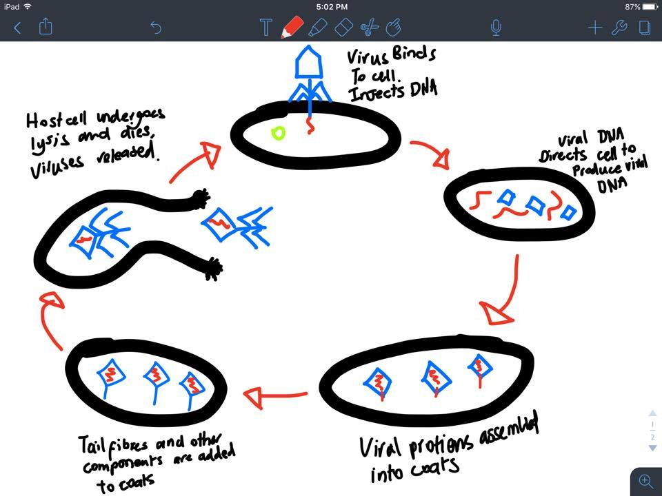

Bacteria
Only a small number cause disease – most not pathogenic

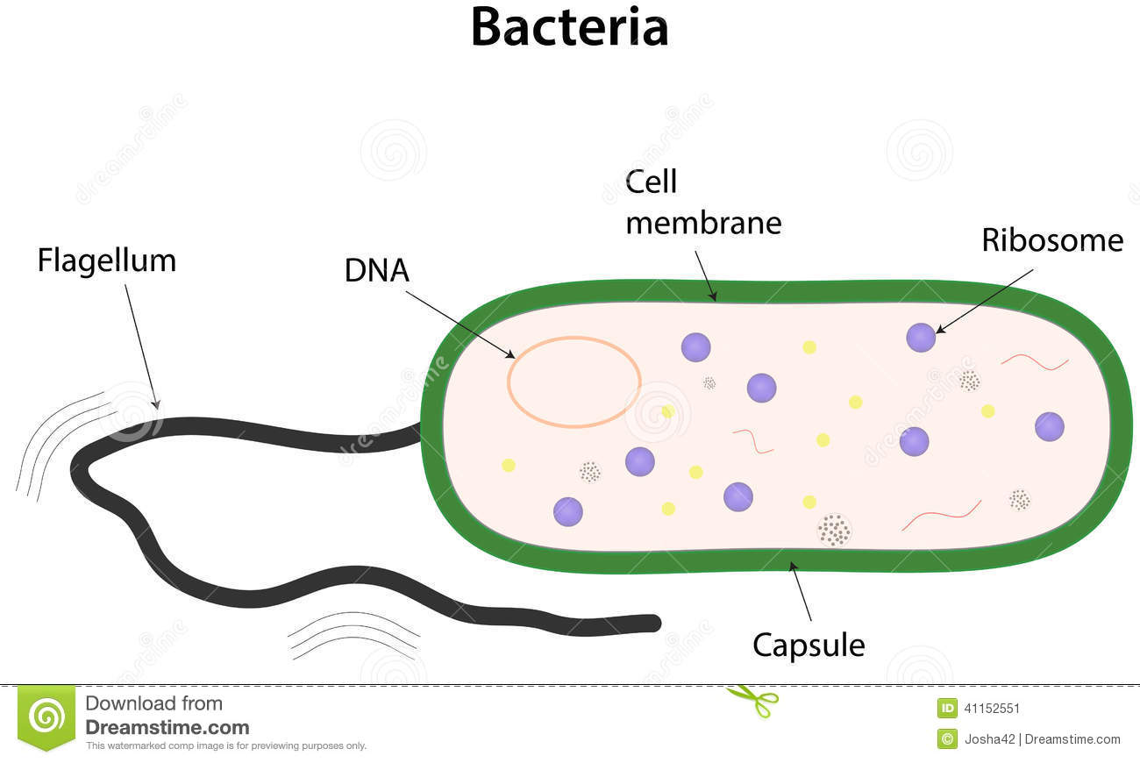
Bacterial Structure:

- Bacteria can also survive in a hardier form called an Endospore – a dormant version of a bacteria – helps in dispersal
- The slimy capsule also helps in sticking to surfaces
- The flagellum helps movement

Bacterial Binary Fission
- Form of asexual reproduction For rapid reproduction

Bacterial Classification and Identification
- Shapes:
  - Coccus (Spherical), Bacillies (Rod), Spirilli (Spiral), Vibrio (Comma)
- Clusters:
  - Diplococci (Two), Streptococci (Chains), Staphylococcus (Clusters)
- Strains:
  - Gram Positive (Purple)
  - Gram Negative (Pink)

Causes of Bacterial Disease
- All modes of transmission
- In host Divide rapidly
- Some damage tissue directly, or release toxins, others interfere with the immune system

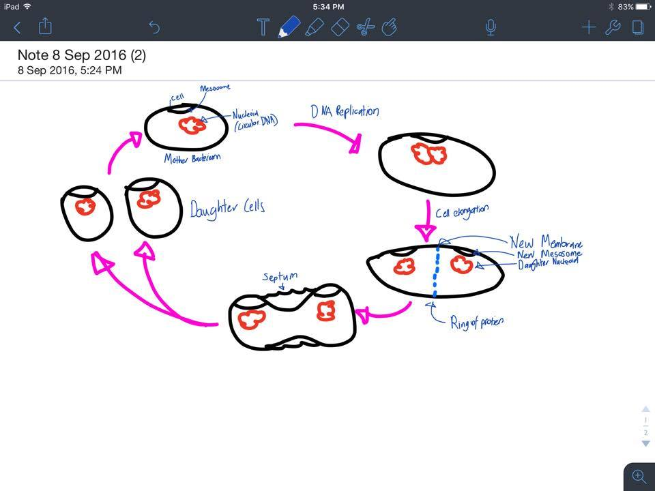
Bacterial Life Cycle:

Fungi
Eukaryotes
Reproduce Spores
Walls made of Chitin
Not all pathogenic

External Fungal Disease
- Most diseases are external
  - Skin irritants
- Produce spores as they grow
  - Infected skin Flakes off Spores go with
  - Causes new infection in damaged skin
- Spores are long lived to improve transmission

Internal Fungal Diseases
- Rare
- Normally harmless unless immune system is weak (AIDS, etc.)

Fungal infections in Plants
- Phytopthora Cinnamomi (Jarrah Dieback)
- Hyphae (finger like branches) of fungi penetrates external surface of roots and enters floem deprives plant of nutrients

Fungal Life Cycle:

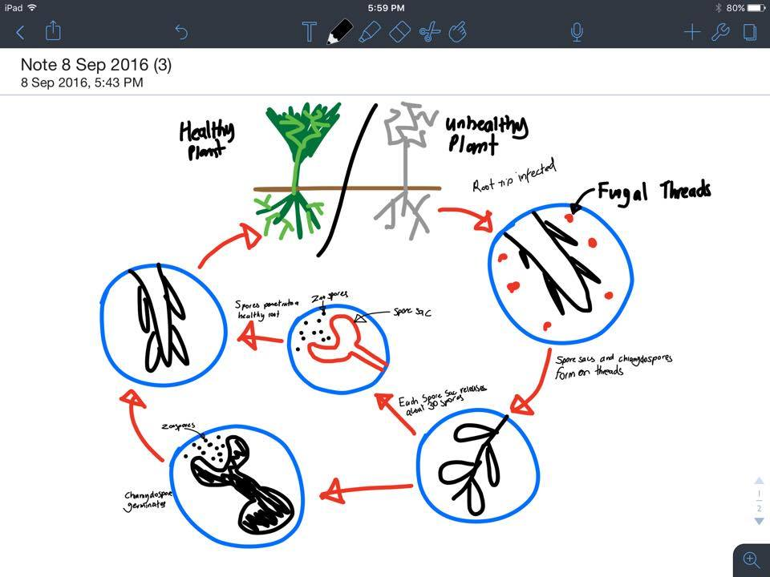

Protists
Unicellular Eukaryotic Organisms
Reproduce Sexually + Asexually
6500 species, less than 24 are pathogens
No effective treatments exist

Major Diseases studied are:
- Tuberculosis (Mycobacterium Tuberculosis) Bacterial Pathogen
- Tetanus (Clostridium Tetani) Bacterial Pathogen
- Crown Gall (Agrobacterium Tumefaciens) Bacterial Pathogen
- Amphibian Chytrid Fungal Disease (Batrachytrium Dendrobatidis) Fungal Pathogen
- Malaria (Caused by Protists: Plasmodium Falciparum, Plasmodium Virax) Protistic Pathogen
- Jarrah Dieback (Phytophthora Cinnamomi) Protist Plant
- Influenza (Human Influenza A+B) Viral Infection
- Ross River Virus (Caused by Alphavirus) Viral Infection
- Viral Disease of Honeybees (Deformed Wing Virus) Virus
- Bat Lyssavirus (Zoonotic Virus) Virus

For more information, refer to A3 sheet for summaries

Public Health

How disease spreads
- Rate of disease transmission varies
  - Sporadic Uncommon, occurs irregularly
  - Endemic Occurs at a constant rate
  - Epidemic/Outbreak Increase above normal rates
  - Pandemic Outbreak that spreads across continents

Pathogen Factors + Transmission
- Mode of transmission can increase spread
  - Malaria Restricted by climate – Vector Area (Mosquito)
  - Influenza Not very restricted – Airborne
  - Hep C Common in needle-sharing communities (Bodily fluid transmission)

Infectivity
- Ability of Pathogen to spread
  - Natural rate varies
- Different to virulence (capacity to cause disease)
- Australian Bat Lyssavirus – High virulence, low infectivity

Resistance
- Persistence in host without showing symptoms (often years TB)
  - Can still transmit

Environmental Structures
- Infrastructure
  - Breakdown of USSR Increase in TB strains
    - Requires effective treatment + collaborations between organisations
- Location
  - Dengue Fever
    - Requires mosquito in urban environments
- Climate
  - Malaria Changing global weather Increase in population
  - Extreme Climatic event can further increase spread of disease

Host Factors – State
- Difference in immunity, susceptibility due to behaviours, age, general health
- Spread depends on density of population
  - Higher Population Quicker Spread

Host Factors – Movement
- Allows disease to spread over large areas
  - Clearly observed when isolated populations come into contact with one another
  - They have no immunity

Preventing Spread of Disease
- Hand Hygiene, Vaccinations, Quarantine

Hand Hygiene
  - Hand washing reduced infection rates, prevented contraction, prevents spread

Immunisation
  - In Australia, children routinely vaccinated
    - Hepatitis B, tetanus, polio

Herd Immunity
  - Not all individuals need to be vaccinated
  - Too few susceptible to sustain spread
  - Number for ‘herd immunity’ varies depending on disease

Anti-vaccinators
  - Some believe causes autism
  - Low vaccination levels can decrease ‘herd immunity’
  - Legislation introduced

Quarantine
  - Stops individuals carrying disease from entering healthy populations
    - Stopped from entering until incubation period has passed
  - Used to prevent spread of all pathogens

Monitoring disease activity
  - Disease actively globally monitored by WHO (World Health Organisation)
  - List of notifiable diseases exist
    - Public authorities notified of diagnosis
    - Limitations: Not all individuals seek care, get diagnosed properly

Managing Outbreaks:

Predicting Disease Spread
- Mechanical models important in control of outbreak
- For model to have good predictability:
  - Needs to reflect complexity of pathogen
  - Host and pathogen and environment relationships

Epidemiology
- Branch of medicine that deals with distribution, incidence, control
- Infectious disease still major cause of death worldwide

Nervous System

Homeostasis
- Organisms have structural features, behavioural responses and physiological mechanisms to help maintain a constant internal state
- Organisms communicate constantly with environment (external & internal)

Principles of Communication
- Production of signal that contains information to be transported
- Detection of signal
- Transfer of signal to target
- Response to signal by target
- Switching odd signal once responded on

Detecting Stimuli
- Simuli may be physical or chemical
- External + internal receptors allow organism to respond to stimuli
- Five main types of receptor:
  - Chemoreceptors
  - Mechanoreceptors
  - Photoreceptors
  - Thermoreceptors
  - Pain Receptors

Exteroreceptors
- Cells that are highly specialised to receive signals from external environment
  - Work by receiving information and converting it to chemical signal that can be relayed between body cells
- Distribution
  - Evenly over body (eg. Pain)
  - Specialised areas (eg. Tastebuds)
  - Concentrated in organs (eg. Eyes)

Interoreceptors
- Receive signals from within
  - Eg. Increase in pH or Co2 levels
- Internal environment created by interstitial fluid + blood plasma
  - Maintained within narrow limits for maximum cellular efficiency

Homeostasis Systems
- Nervous + endocrine system responsible for monitoring changes and coordinating responses in complex organisms

Nervous System
- Comprises central nervous system (CNS)
  - Brain and spinal chord
  - Responsible for processing, storing + coordinating information
- Peripheral nervous system (PNS)
  - Made up of other neurons
  - Transmits into and from CNS

Neural Pathways
- Impulses follow sensory neurons from source of stimulation via PNS to CNS
- Impulses relayed via interconnecting neurons
- Motor neurons relay signal via PNS to effectors (responsive muscles and glands)

Cervical Nerves – 8 Pairs – Neck, Shoulders, Arms
Thorassic Nerves – 12 Pairs – Trunk & Arms
Lumbar Nerves – 5 Pairs – Legs & Lower Back
Sacral Nerves – 5 Pairs – Legs & Genitals
Cocygeal Nerves – 1 Pair – Vestigial

Neurons
- Basic unit of nervous system
- Tubular extension = axon
  - Enclosed in a fatty material (myelin sheath)
- Myelin composed of Shwann cells
  - Leaves small nodes (of Ranvier) along axon
  - Assists in transmission (more myelin, faster conduction)
  - Created by oligoden drocytes

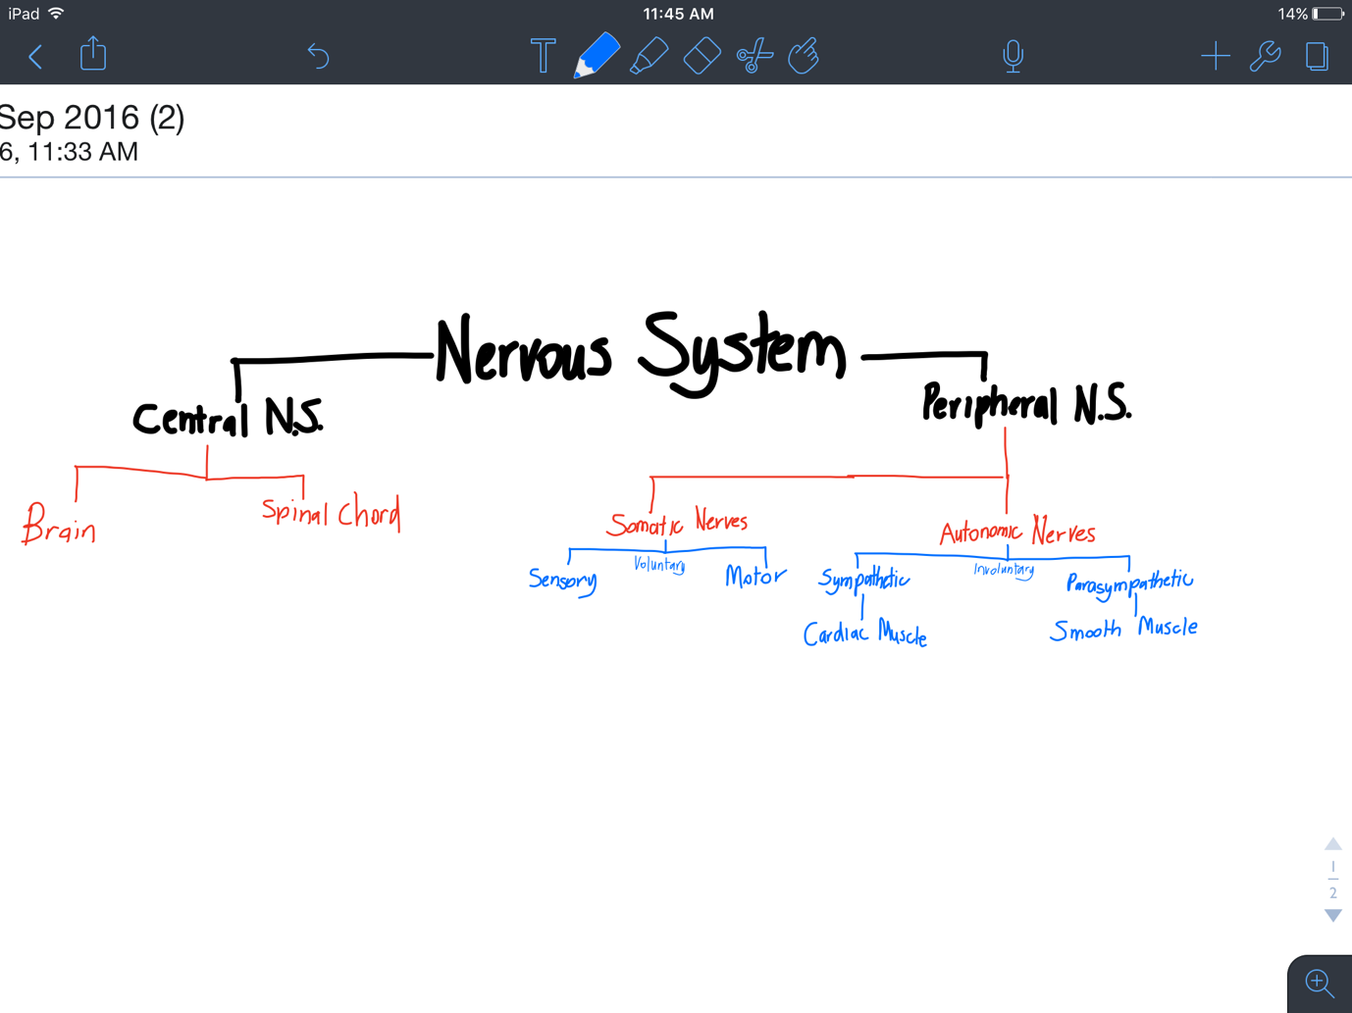
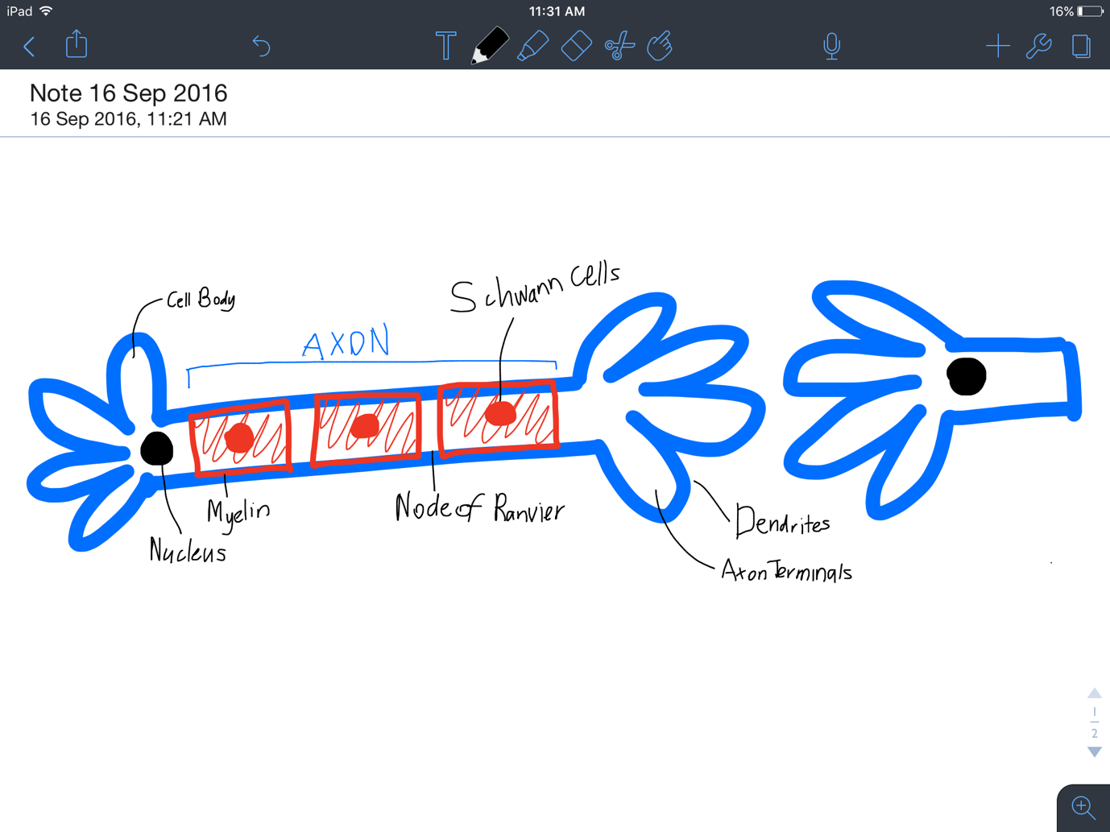

Endocrine System
Some changes are slow and under control of hormones
Not all require immediate response

Hormones
- Chemical substances from endocrine system
- Secreted straight into the bloodstream
- Target & activate certain cells / organs and cause response
  - Cells must have specific receptors

Hormone Effects
- Some temporary (eg. Adrenaline), some longer (eg. development of a foetus)
- Co-ordination of activities often connected to pituitary gland
  - Produces many hormones that affect hormone production by other glands

Other Animals
- Ring doves coo to release hormones for egg development

Importance of Response (1)
- Developmental processes, growth & reproduction
  - Failure in signalling pathways can lead to uncontrolled cell growth
  - Failure to respond to apoptosis can lead to malformations
  - Differentiation of stem cells during reproduction

Importance of Response (2)
- Homeostasis
  - Keeping concentrations equal
  - Movement of materials
  - Activities of enzymes

Importance of Response (3)
- Surviving challenges in external environment
  - Predators

Feedback Loops & Tolerance Limits

Optimal Levels
- Organisms have narrow ranges for internal temperature and fluid concentrations
- Minor fluctuations always occur
  - Eg. Disease, extremes trauma
- Must be controlled quickly

Feedback Mechanisms
- Signals about disturbances fed to control centre
  - Interprets & coordinates specific response that counteracts or reinforces disturbance
- Called feedback mechanisms

Controlling Response
- Once signal is responded to, it must be switched off (otherwise waste of energy/cell damage)
- Disrupt signal pathway
- Remove original stimulus
- Respond in a way that alters original signal (feedback)

Types of feedback:

Negative Feedback
  - Mechanisms that counteract the stimulus
  - Eg. Eat Chocolate Increase Blood Glucose Glucose Removed Converted to Glycogen

Positive Feedback
  - Mechanisms that reinforce the original stimulus
    - Eg. Thyroxin rises Can trigger metamorphosis from tadpole to frog
  - Can be harmful
    - Eg. Increased temperature during fever New higher set point established
    - May lead to heatstroke

Tolerance Range
- Range in which different levels of materials, pressure & temperature can be tolerated
- Homeostasis maintains levels within optimum range
- If fails, organism can fall into state of psychological stress

Metabolic Activity
Metabolism
- Sum of chemical reactions that occur in an organism to maintain life
- Mostly require help from enzymes (which function at particular pH/temperature)
Metabolic Activity Can Create Heat
- Increased activity increased internal temperature
All Connected
- Increase CO2 Decrease pH Decreased Enzyme Function Decrease Metabolism Decrease Heat

Physiological Processes – Exercise
- Increase in breathing rate to remove CO2
- Thermoreceptors signal for sweat glands to operate to lower body temp

Structure & Behaviour
- Remove clothing, moving into shade

Heat Regulation

Internal Temperature
- Different animals have different internal temperatures
  - Determines the optimum range for enzyme function
- Too high Enzymes denature, metabolism fails, hyperthermia
- Too Low Enzyme function slows, metabolism fails, hypothermia

Endotherms
- Retain heat generated by metabolic activity in their bodies
  - Usually Homoeothermic
    - Can maintain a relatively constant body temperature

Ectotherms
- Depend on absorbing heat from external environment
  - Usually Poikilothermic
    - Cannot control internal temperature – fluctuates with surroundings

 | Homoeothermic | Poikilothermic
Endotherms | Kookaburras, Penguins, Emus, Koalas  Retain heat generated from metabolic activity and can maintain constant body temperature. | Fast swimming fish (Tuna)  Cannot control heat (fluctuates) but keep heat from metabolic activity
Ectotherms | Desert Lizards, Tropical marine invertebrates  Can maintain relatively constant body temperature | Snakes, Lizards, frogs  Cannot maintain control internal body temperature, and depend on the environment

Strategies for thermoregulation
- Heat transfer depends on temperature gradient between internal and external environment
- Purpose of thermoregulation
  - Find balance between heat loss and heat gain (heat balance)
  - Usually involves interaction of physiology, structure and behaviour

Heat Loss & Gain

Conduction | Transfer of eat from hot to cold through direct contact
Convection | Transfer of heat when hot air rises and is replaced by cooler air or water
Evaporation | When water/sweat turns to vapour, cooling
Radiation | When heat is transferred from object by infrared waves

Staying Cool in the Heat
- Endothermic homeotherms (Retain heat from metabolic activity, maintain internal temperature)
  - Need to be able to reduce heat gain and increase heat loss

Physiological adaptations

Vasodilation | Arterioles widen to increase blood flow to the skin where heat can evaporate
Arrector pili Muscles Relax | No insulating later trapped at the skin
Sweating | Water evaporation increases cooling from the skin
Metabolic processes stay steady until body’s cooling mechanisms fail | Metabolism produces heat

Behavioural Adaptations

Shelter from high temperatures | Reduced contact with higher temperatures can reduce temperature gain
Lick wrists where blood vessels are dense | Increases evaporation from the surface and cools the surface and such cools the blood
Submerge in water | Reduces body temperature by direct contact with cooler water
Moulting | Reduced hair reduces alibility to hold heat and thus can reduce heat gain
Lay/Spread out | Increased surface area increases heat loss
Open Mouth | Increases evaporation from internal structures

Structural Adaptations

Smaller animals live in warmer climates | Increases surface area : volume ratio for heat loss
Larger Ears | Increases surface area
Light Coloured Fur/Hair | Reflects light to reduce heat gain

Staying Warm in the Cold
- Endothermic Homeotherms (Retain heat from metabolic activity, maintain internal temperature)
  - Need to be able to increase heat gain and reduce heat loss

Physiological Adaptations

Vasoconstriction | Arterioles construct to limit blood flow to extremities (ie. hands and feet)
Piloerection | Arrector Pili muscles contract, raising hair in order to trap layer of air to act as insulator
Counter-Current Heat Exchange | Blood in arteries to foot/fins, warms blood returning in veins (Penguins)

Behavioural Adaptations

Huddling | Decreases overall surface area exposed to elements (Penguins)
Nests not usually made | Young must huddle against parents which decreases SA:VOL ratio for heat loss
Migration | Movement to different climates that may be more adequate for survival

Structural Adaptations

Feathers, Fur, Fat | Acts as an insulating layer
Larger Animals in Colder Environments | Decreases SA:VOL ratio for heat loss
Small Ears | Minimise SA for heat loss

Hibernation
When homeostasis doesn’t work
Hibernation involves metabolic rate falling to a level the just sustains life

Lower & Upper Critical Limits
- Lower Critical Limits
  - Temperature where metabolic rate rises, increasing heat output
- Upper Critical Limits
  - Temperature where body’s cooling mechanisms fail and metabolic rate increases with external temperature

Aestivation
- Occurs in sometimes dry conditions
  - Snails retreat into shell & seal off

Kidneys

Water
- Universal Solvent – essential to life
  - Most salts and mineral broken into ions by water creating aqueous solutions
  - Metabolic reactions occur in solution composed of water

Osmoregulation
- Water balance requires continuous homeostatic control
- When supply does not meet loss, concentration of solute vs. solvent in tissue fluid becomes difficult to regulate
- Physiological functions affected
- EG:
  - Loss in blood volume Pressure drops
  - Wastes not excreted efficiently
  - Enzyme function affected
  - Dehydration can lead to death / collapse of shoot systems (plants)

Kidneys
- Important for homeostasis/osmoregulation
  - Remove nitrogenous wastes
  - Regulate water concentration in blood
  - Maintain ion levels in blood

Nitrogenous Wastes
- Formed via deamination (the removal of an amino group from an amino acid)
- Ammonia/Urea toxic – affects pH

Freshwater Fish | Lots of Dilute Urine with ammonia, excreted quickly/continuously to prevent build up (toxic in high levels)
Marine Fish + Terrestrial Animals | Convert ammonia to urea, released as urine (small amount)
Reptiles & Birds | Produces Uric Acid, least toxic form of nitrogenous wastes with very little water

Kidney Osmoregulation
- Controlled by antidiuretic hormone (vasopressin)
  - Secreted from neurosensory cells in hypothalamus when osmoregulators detect increase in blood solutes
- Increases permeability of distal tubule (kidney)
  - As water concentration increases in blood plasma, negative feedback decreases release of vasopressin

Osmoregulators & Osmoconformers

Water Maintenance
- Different organisms have various ways to maintain water balance
Osmoregulators
- Regulate osmotic concentration to be higher or lower than external environment
Osmoconformers
- Allow osmotic concentration to be equal to external environment

Osmoregulators – Structural Features
- Waterproof/impermeable outer layer to reduce water loss
  - Eg. Scales, hair, feathers, epidermis
- High densities of sweat pores in highly exposed areas
- Longer Loops of Henle

Structural Plant Features
- Water constantly lost through stomata
- Maintain water balance by:
  - Thick waxy cuticle
  - Reduced stomata on top – more underneath to prevent water loss
  - Sunken stomata – to prevent water loss through contact with air
  - Cylindrical/Rolled leaves
  - Reduced/no leaves
  - Hairs on leaves
  - Taproots

Osmoregulators – Physiology
- Reabsorption of water from kidney
- Excretion of nitrogenous wastes as urea or uric acid
- Slower production of urine
- Antidiuretic hormone (vasopressin)
- Metabolising of fat to produce water

Aquatic Organisms
- Marine organisms have body fluids that tend to be hypotonic (fresh)
  - Body fluids have lower solute concentrations than the external environment
- Freshwater organisms have body fluids that tent to be hypertonic (salty)
  - Body fluids have higher solute concentration than the external environment

Osmoregulators – Behaviours
- Burrowing
- Hibernating
- Aestivation (prolonged torpor or dormancy of an insect, fish, or amphibian during a hot or dry period)
- Wrapping tail around face

Osmoconformers
- Most marine invertebrates
- Interstitial fluid concentration fluctuates to match external environments
  - Fluids are isotonic (same)
- Organisms that can tolerate fluctuations in salinity known as euryhaline species

